**PSY 653 Module 1: Nested and Incomplete Designs**

**Jan 27, 2021**

Use the “Nested_practice.csv” datafile to practice conducting a nested ANOVA on your own.

This datafile includes data from 114 patients who participated in study to evaluate the effects of different drugs and treatment conditions on their health. This demo dataset has four variables:

* 1. **Y** = the outcome variable for health (Possible values = 1 – 15)
  2. **Hospital** = Hospital (i.e., there were two hospitals)
  3. **Drug** = Drug (i.e., four different drugs were tested)
  4. **Condition** = Condition (i.e., twelve different treatment conditions were tested)

1. This is the underlying structure of the data:

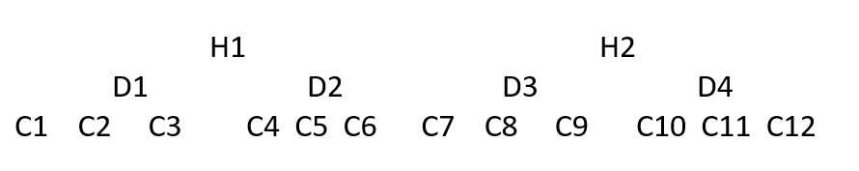

* 1. How are the variables nested?
  2. Based on how the variables are nested, how does this nesting impact your analysis plan? Is it possible to run an interaction? Why or why not?

1. Create a new R-chunk with a first level header: “Load Libraries”
   1. Load the psych and tidyverse packages
2. Create a new R-chunk with a first level header: “Import data”
   1. Read in the datafile “Nested_practice.csv”
3. Create a new R-chunk with a first level header: “Get variable descriptives”
   1. Use any method to get variable descriptives
4. Create a new R-chunk with the first level header: “Get grouped means”
   1. Use the aggregate function (or a combination of group_by() and summarize() ) to calculate the mean values of Y by Hospital, Drug, & Condition (You will get three sets of descriptive).
5. Create a first level header: “Visualize the data”
   1. In their own separate R-chunks, create the following boxplots:
      1. Y by Hospital
      2. Y by Drug faceted by Hospital
         1. Looking at this graph, is an interaction possible? Why or Why not?
      3. Y by Condition faceted by Drug & Hospital
         1. Hint: to facet wrap by two variables you will need to use “vars(var1, var2)” instead of a “~” in your facet_wrap().
         2. Looking at this graph, is an interaction possible? Why or Why not?
6. Create a new R-chunk with the first level header: “Run nested ANOVA”
   1. Run an ANOVA that properly utilizes the nested structure of the data.
      1. Calculate the eta squared for each of your coefficients.
         1. Hint eta squared = SSeffect / SStotal
      2. Interpret the results.